SCREENSHOT OF SYNTAX:
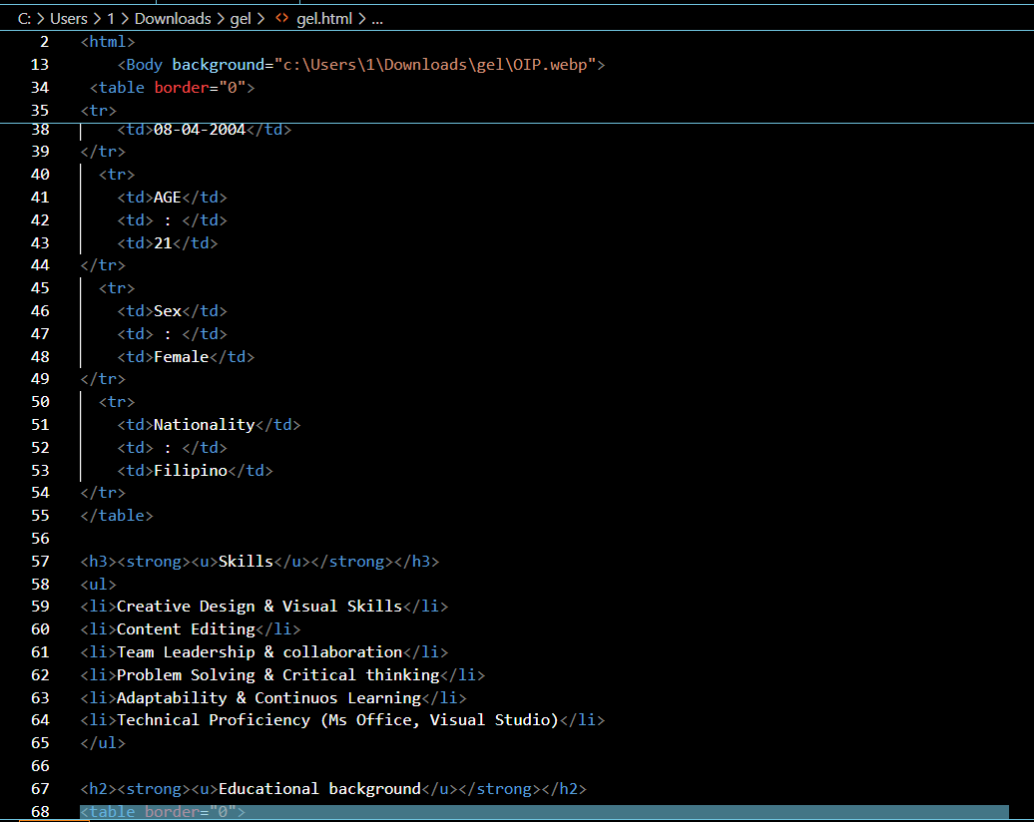
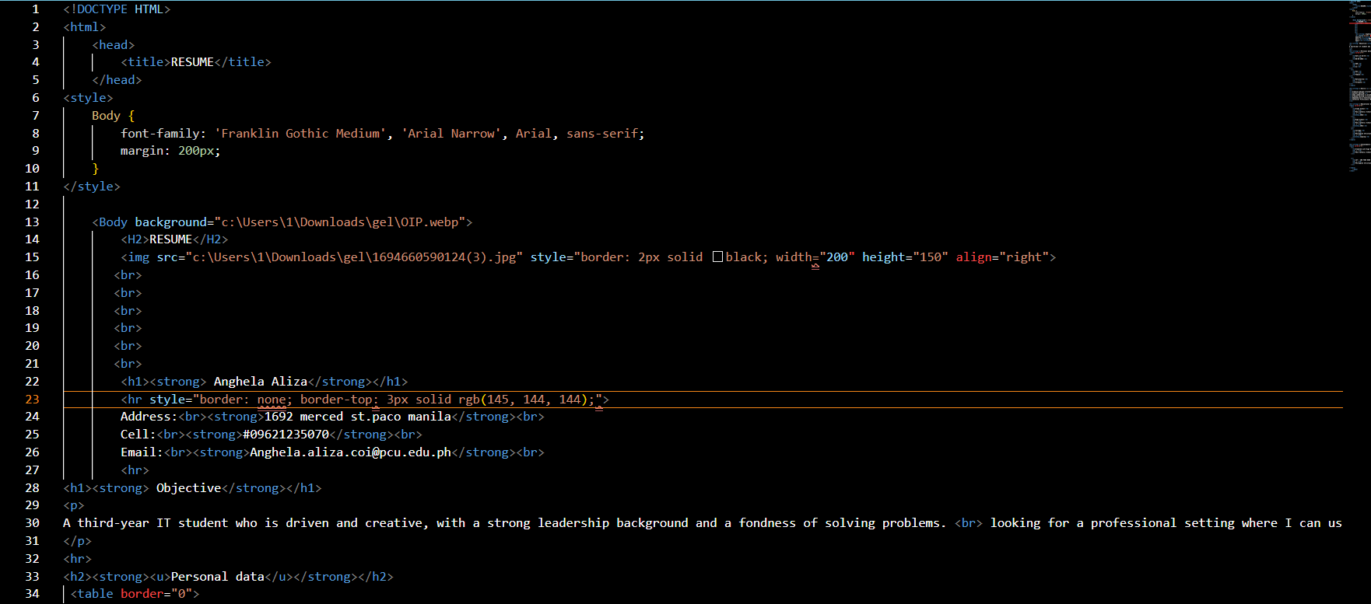

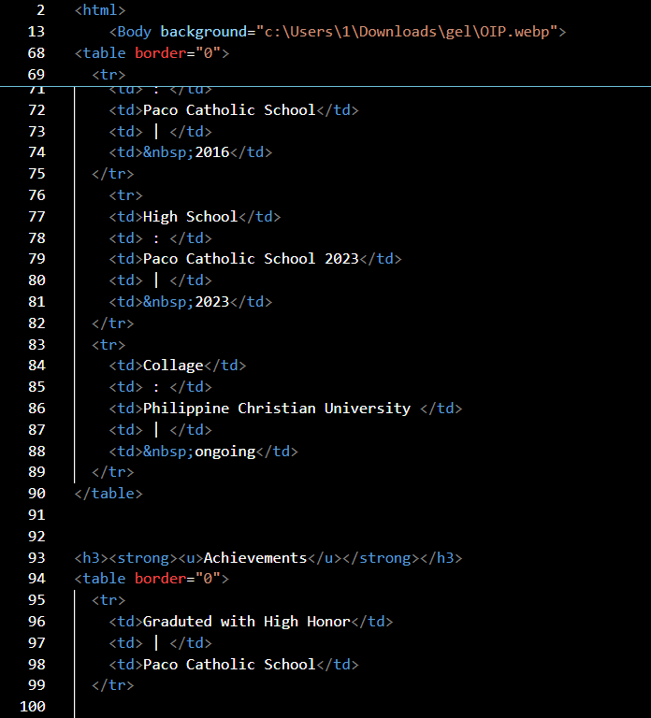

SCREENSHOT OF OUTPUT:
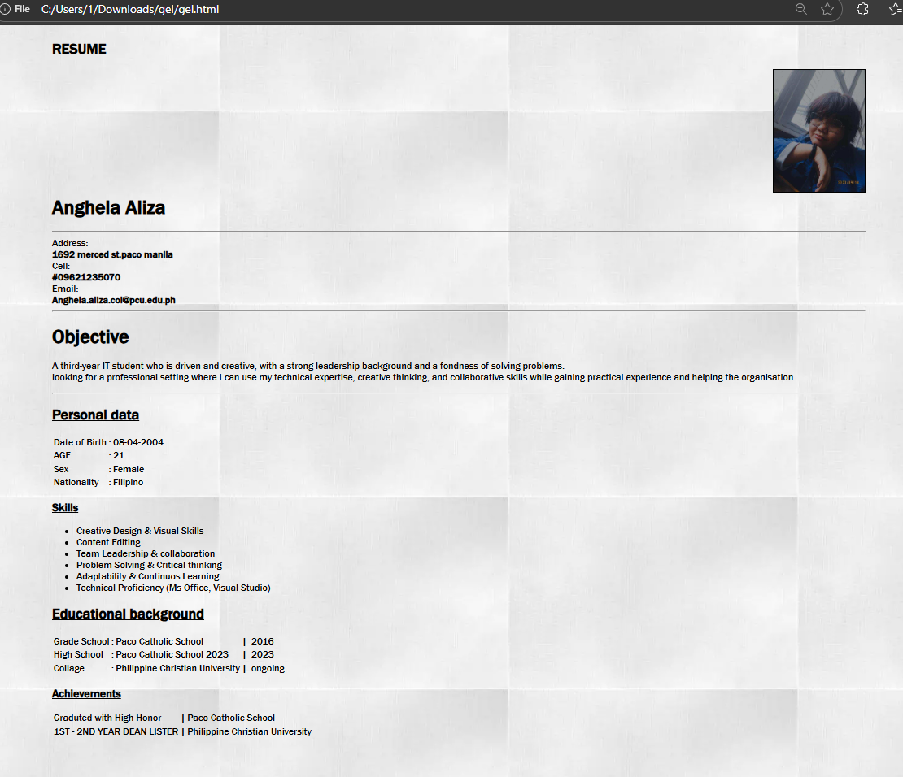

SCREENSHOT OF SYNTAX WITH PROVIDED EXPLANATION:
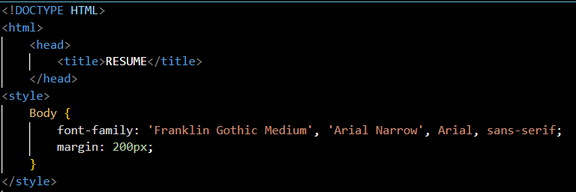

THIS PART is responsible for the design format of the resume.
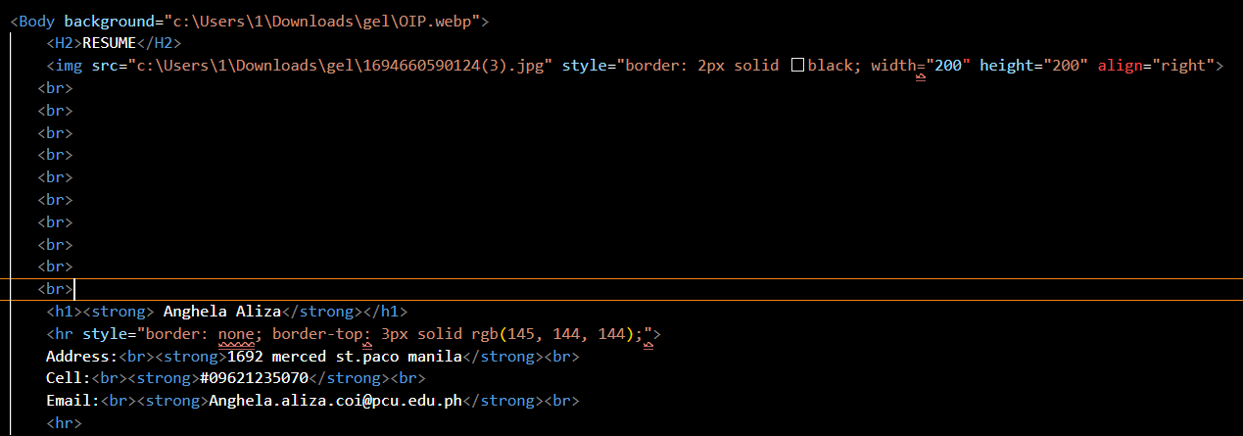
THIS PART is for the background design and the picture used for the resume, also the <br> is just for the space to look presentable for the output.

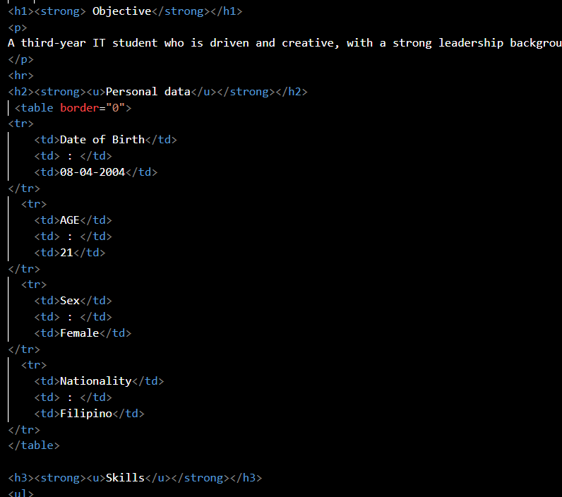
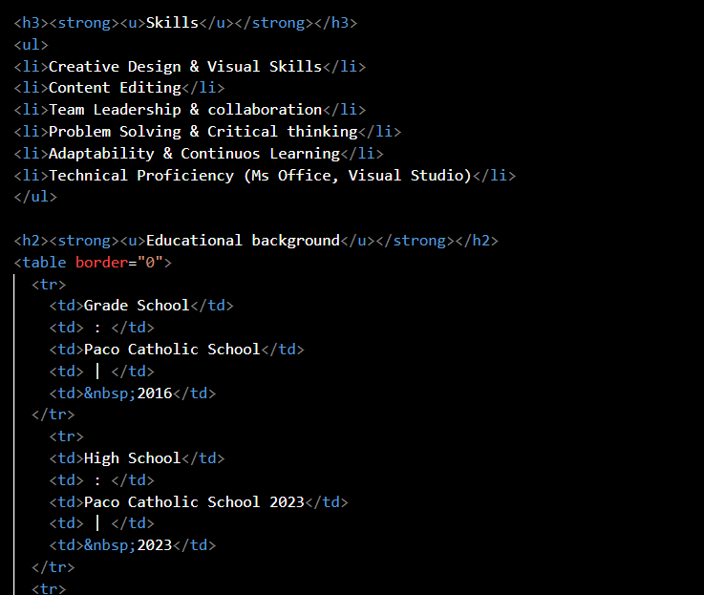
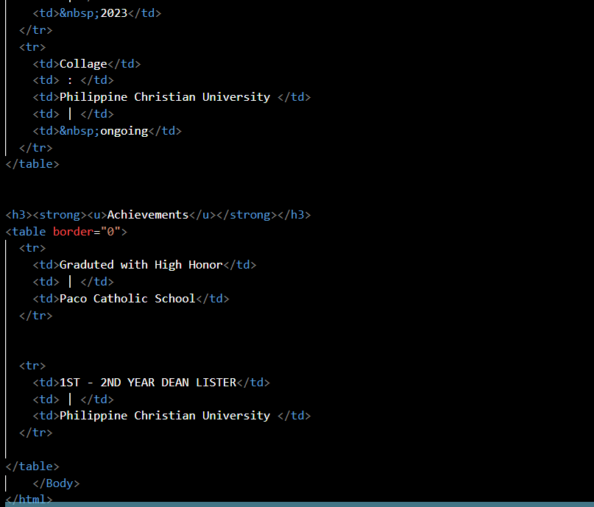

In this part I combine the <td> for the table and format it with 0 border to make an invisible spaces to make it more organize, also I used the bullet <li> for maintaining clean output.

